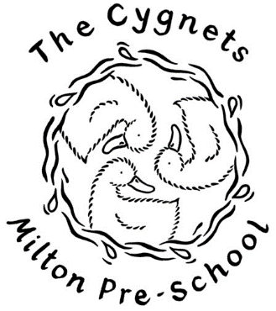

6.10 Sun Protection Policy September 2023

Too much exposure to ultraviolet (UV) radiation from the sun causes sunburn, skin damage and increases the risk of skin cancer. Sun exposure in the first 15 years of life contribute significantly to the lifetime risk of skin cancer.

At Cygnets Pre-School Milton we want all staff and children to enjoy the sun safely. We will work with staff, parents, and carers to achieve this through:

Education
- All children will be involved in a discussion, appropriate for their age and understanding, at the start of summer about sun protection and the risks.
- All staff will be educated in the importance of sun protection and the risks involved in not protecting both themselves and others.
- Parents and carers will be informed about our policy.

Sun safety will be promoted through working with parents, staff, and the wider community to improve our understanding and provision to avoid the harmful effects of too much exposure to UV. Staff will act as positive role models and set a good example by seeking shade whenever possible, wearing appropriate clothing, and applying suncream.

Protection
- The pre-school garden has shade provided by the large sail.
- The decking area is completely covered and we use this regularly when it is particularly sunny. When the sun is strongest, we close the garden but this sheltered area ensures that the children can still learn in our outside area
- Children will be encouraged to use the shaded areas when appropriate and use of the garden between 12-3 will be limited on the hottest days.

Clothing
- The children will be encouraged to wear clothes that provide good sun protection (sun hats etc)
- Parents are encouraged to ensure their child is wearing sun protective clothing such as broad-brimmed hats, loose, long-sleeved tops and long skirts or trousers and sunglasses.
- Parents/carers will be regularly reminded about the importance of ensuring their child has a named sun hat at pre-school.
- Staff should wear hats when appropriate to act as good role models.
Water
- Children are encouraged to increase their water intake in hot weather and are encouraged to do so in outdoor areas also.
- Water will always be available to children throughout the day from their water bottles which children will be able to access independently.

Suncream
- Children attending a half-day sessions are expected to arrive at pre-school wearing a suncream to protect them for the duration of their session. This suncream is to be a minimum of a factor 30+ and must have been opened within a one-year period.
- For those children attending a full day session, parents should apply cream to their children before they come to pre-school and staff will assist the child in re-applying suncream during the day when necessary.
- The sun cream used by pre-school will be Nivea Sun, Kids protect and care 50+ 5* UVA. Parents are asked for a voluntary donation of £1 for the year towards the cost of the suncream.
- In the case of allergies or sensitive skin, parents can provide a sun cream to be kept in setting for the duration of the summer. This suncream must be at least a factor 30+ or above and be clearly labelled with the child’s name and the date it was opened. This lotion will be stored on the medication shelf in each classroom.
- Parents are asked to give permission via Famly for suncream to be applied to their children.
- Children attending for full day sessions will be supported to reapply it at lunchtime on days where we deem it necessary. We will use the UV index sourced from the Met Office as a guide. Children will be encouraged to develop responsibility for applying their own cream with support and supervision of a member of staff.

Adoption and annual review of the policy
This policy was adopted at a meeting of: | The Cygnets Milton Pre-School
held on: | 18/09/2023

Signed on behalf of the  Management Committee / Proprietor: | Lianne Stanford
 | Lianne Stanford- Chair of Committee

This policy was reviewed on:

